**CREATING THE UI TO INTERACT WITH APPLICATION**

**HOME PAGE:**

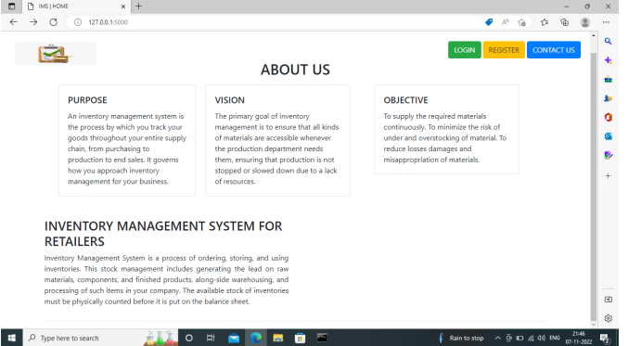

LOGIN PAGE:

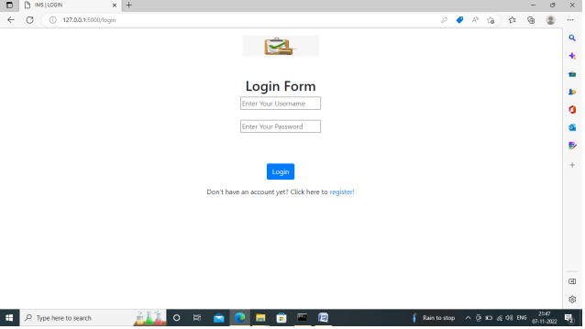

REGISTER PAGE:

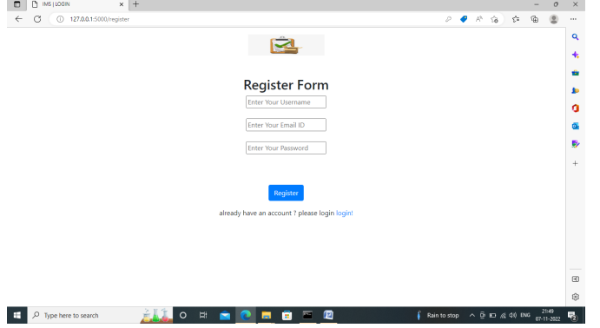

AFTER THE LOGIN:

ADD PRODUCTS:



OUTGOING THE ORDERS:



INCOMING THE PURCHASE:

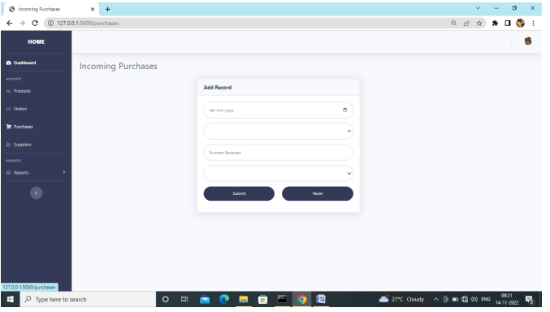

ADD SUPPPLIERS:

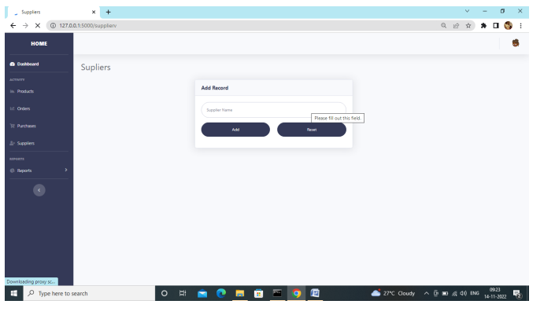

PRODUCT LISTING:

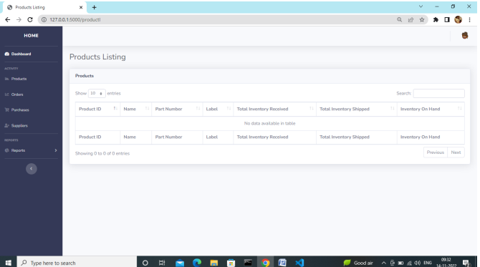

ORDERS LISTING:

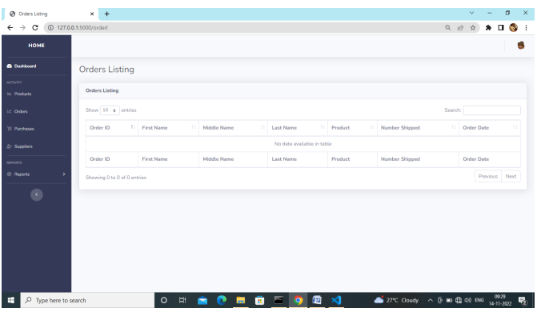

PURCHASE LISTING:

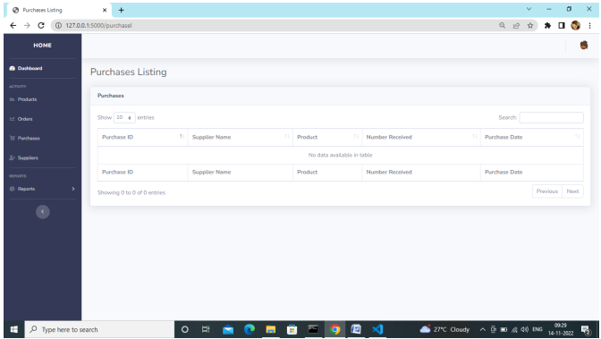

AFTER REGISTER REDIRECT TO LOGIN PAGE:

